

30 August 2021

Paper Work Automation

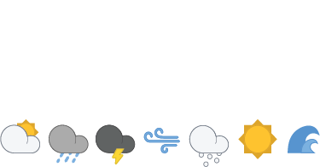

# Purpose

The purpose of this document is to inform the reader about the proposed Software development to Auto fill fields using CSD data. This Document will cover a basic overview and syntax requirements needed to create template files.

Daniel Forbes

MetService

30 August 2021

The information contained in this report, including all intellectual property rights in it, is confidential and belongs to Meteorological Service of New Zealand Ltd. It may be used by the persons to which it is provided for the stated purpose for which it is provided and must not be disclosed to any third person without the prior written approval of Meteorological Service of New Zealand Ltd. Meteorological Service of New Zealand Ltd reserves all legal rights and remedies in relation to any infringement of its rights in respect of this report.

# Contents

Purpose 2

Contents 3

Summary 4

1.1 Goal of automating 4

1.2 Design constraints 4

1.3 Design decisions 4

Software Overview 5

1.4 System Overview 5

1.5 Syntax notes 6

1.6 Imported Library notes 7

Future Work 9

# Summary

## Goal of automating

The goals for this project:

* reduce human error, and the need to fix simple mistakes such as miss typing.
* reduce time doing paperwork, allowing employees more hands on work.
* reduce use of paper, helping the environment.

## Design constraints

Software design constraints:

* For this software to work it would need to be flexible and integrate with word documents.
* Be able to handle file directories.
* Must have an easy to understand GUI (Graphical User Interface).
* Simple to use.
* Can be improved on easily.
* Built in house, no third party, for fast prototyping.

## Design decisions

HTML was considered but this would require considerable work to implement as a web based service which would include AWS (Amazon Web Services) to run as a cloud server, this would have also needed to include C++ for the User Interface and JavaScript to run the calculations and text parser. This option would be better but would require more time and skill to have a working product.

Python was chosen because it could interface with file structures as well as word documents, excel spread sheets and text files. Python also has a simple GUI system integrated with it.

# Software Overview

## System Overview

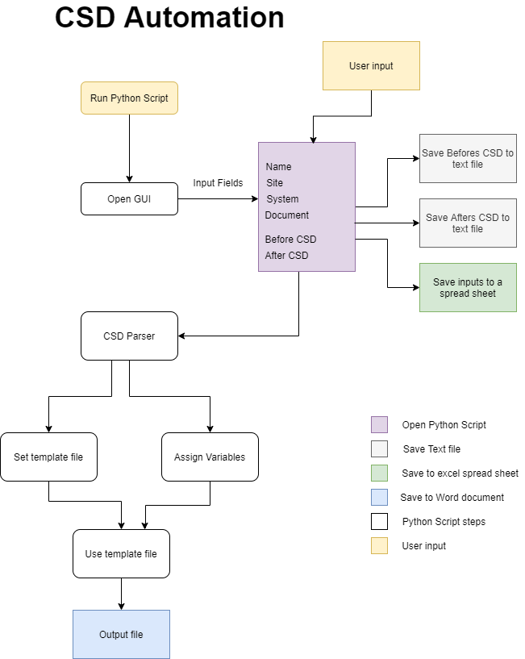

## Syntax notes

Syntax example

# //////////////////// Software Variable Names /////////////////////////////

# Software version

AABeforeVales1 = ""

AABeforeVales2 = ""

AABeforeVales3 = ""

AABeforeVales4_6 = ""

AABeforeVales7_9 = ""

# //////////////////////////Document Names /////////////////////////////

 "AA_BV1": AABeforeVales1,

    "AA_BV2": AABeforeVales2,

    "AA_BV3": AABeforeVales3,

    "AA_BV4_6": AABeforeVales4_6,

    "AA_BV7_9": AABeforeVales7_9,

| **CSD Message Data Checks** | Record BEFORE Testing | | Record AFTER Testing | |
| --- | --- | --- | --- | --- |
| Measured Parameter, field in () | Before | Status G 🗹 | After | Status G 🗹 |
| $AA (1) Software version  (2) Station identifier  (3) Message interval (minutes)  (4...6) ss:nn:hh  (7...9) dd/mm/yyyy | {{ AA_BV1 }}  {{ AA_BV2 }}  {{ AA_BV3 }}  {{ AA_BV4_6 }}  {{ AA_BV7_9 }} |  | {{ AA_AV1 }}  {{ AA_AV2 }}  {{ AA_AV3 }}  {{ AA_AV4_6 }}  {{ AA_AV7_9 }} |  |

Software notation of words is used in replacement for a space is a capitalization is used for the next word. E.g “Hello my name is” turns to “HelloThereMyNameIs”

The syntax created comprises of the first two characters “AA” being the same as the field from the CSD then the next word is either Before or After, the next Word is either Values or Status, the last number denotes the position the CSD data is in.

For the Word document the same logic Applies but there is a “_” after the first two characters then just the first letter is used for the words.

## Imported Library notes

import PySimpleGUI as sg

from PySimpleGUI.PySimpleGUI import Input

import pandas as pd

import os

import sys  # Standard Python Libraries

from docxtpl import DocxTemplate, InlineImage  # pip install docxtpl

from docx.shared import Cm, Inches, Mm, Emu  # pip install python-docx

* ***PySimpleGUI***

Handles the GUI

* ***pandas***

Handles the reading user input

* ***os***

Handles the saving files

* ***sys***

Handles the talking to operating system

* ***docxtpl***

Handles to word files

* ***python-docx***

Handles word files

# Future Work

Currently this report shows an MVP (Minimum viable product) for the use of this software. The only template file that shows this is **mSTAR_FTS.docx**

The future work that would be worth doing would be:

* Adding a function where it reads the CSD data and adds on field test sheets for the sensors present in the CSD.
* Implement inspectors values into the user input.
* Finish implementing other documents to the template files.
* Add search engine to look up sites.